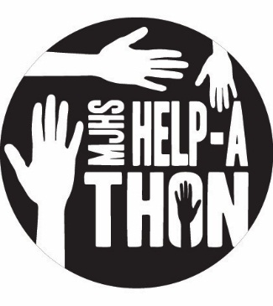

August 20, 2018
Dear MJHS Parents,
We are excited for another Help-a-thon at MJHS. It is our hope that this Help-a-thon will not just raise funds for MJHS but more importantly give students an opportunity to serve in the community and grow as individuals.
Our Help-a-thon is similar to a walk-a-thon, but instead of students collecting pledges to walk, students will seek donors to sponsor their involvement in a service project within our community. We have organized a number of volunteer opportunities that will be completed on October 2nd during our Help-a-thon Community Day. In addition to the service projects on October 2nd, students who collect at least $200 in pledges will participate in a fieldtrip on October 23rd, which will include an additional service opportunity.
Another component of our Help-a-thon is raising money for charitable organizations (this will reduce the number of times throughout the year when we ask families to donate to charitable causes). Ten percent of the money raised by the Help-a-thon will be donated to organizations including: Children’s Hospital, American Heart Association, and the Morton Helping Hands fund, a component fund of the Morton Community Foundation.
We encourage all students to collect pledges, since they will all participate in the Help-a-thon Community Day and receive a t-shirt. The money that is raised by this event will be used to offset fieldtrip costs for families and help purchase athletic, music, and academic items for the school.
Important dates:
- August 21 – Help-a-thon Kickoff (students will receive packet and can begin collecting pledges)
- September 7 – Fundraiser concludes (pledge envelopes turned into homeroom teacher)
- October 2 – Help-a-thon Community Day
- October 23 – Fieldtrip/service project for students who collect at least $200
Guidelines:
- Each sponsor making a pledge should write their information on the pledge form/envelope
- Pledges collected by September 7
- Make checks payable to MJHS PTO
- All donations are tax-deductible
On behalf of the students and staff at Morton Junior High School, we want to sincerely thank you for your support of our school and Help-a-thon.
Sincerely,
MJHS PTO (Red and White Club)

